Electronics Laboratory
And
Students’ kits
For

Self-Study

And

Distant Learning

By: Charbel T. Fahed
Table of Contents

- DC and AC Fundamentals

  - Color Code
  - Ohm’s Law
  - Series Circuits
  - Parallel Circuits
  - Series-Parallel Circuits
  - Voltmeter Loading
  - Superposition Theorem
  - Thevenin’s Theorem
  - Wheatstone Bridge
  - RC Wave Shapes

- Logic Circuits and Systems

  - The breadboard and logic designer
  - Logic Gates
  - Gates Equivalents
  - Combinational Logic Networks
  - Digital Multiplexers/Data Selectors
  - Latches
  - Flip-Flops
  - Four-Bit Ripple Counter
  - 555 Timer

- AC Circuits

  - Oscilloscope Operation
  - Reactance of Capacitors
  - Series LR Circuits
  - Frequency Response Of RC Circuits
  - Impedance of LRC Circuits
  - Impedance of Parallel RC, RL, and RLC Circuits
  - Characteristics of Series Resonant Circuits
  - Tank Circuit Filter
  - Iron Core Transformer

- Electronics I – Devices

  - Junction Diode Characteristics
  - Clipper/Clamper
  - Zener Diode Regulator
  - Bridge Power Supply
  - Transistor Familiarization
  - DC Characteristics of s Transistor
  - Transistor Beta and Collector Current Ceiling
  - Voltage Divider Biased Transistor
  - JFET Amplifier
  - Push-Pull Class B Amplifier

- Electronics II – Operational Amplifiers

  - Class A Amplifier
  - Frequency Effects
  - The 741 Operational Amplifier
  - IC Differential Amplifier
  - Wien Bride Oscillator
  - LC Oscillators
  - Transistor Regulators
  - IC Voltage Regulator

LAB REPORT OUTLINE FOR ELECTRONIC EXPERIMENTS

1. Explain objective of experiment.

2. What are you going to measure?

3. What do you expect the results to be?

4. Divide experiment into parts.

a) Show measurements and results for each part.

b) Make sure that each step clearly shows what circuit was used plus the corresponding waveforms, amplitude, frequency, etc...

5. Conclusions

a) Did the experiment verify what you expected?

b) Were there any unexpected or surprising results?

Grading Will Be Based On:

1. Neatness
2. Organization of Material
3. Explanation
4. Correctness
5. Grammar and Spelling
- Style

LAB REPORT FORMAT
APPROPRIATE CONTENT SEQUENCE FOR EACH REPORT

All sheets 8 ½” x 11” Stapled together at upper left hand corner

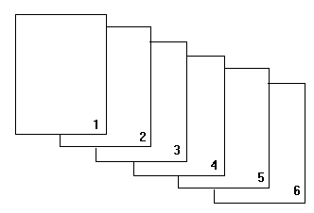

1. Proper cover sheet
2. The completed experiment handout (if a textbook is used: copies of data tables)
3. Graphs and Waveform sheets if required
4. Calculations as required
5. Questions and Answers

The paper for 3, 4, 5 (and 2 if a lab text book is used) is quadrille ruled paper with five squares per inch.
The grade earned on each report is base on:
Completeness
Accuracy
Quality of rendering

Rendering

1. Report must be neat and clean.
2. Proper grammar and spellings must prevail. Must use black ink.
3. Each graph and Waveform sheet must have a title.
4. Each graph curve and wave form sketch must be labeled if there is more than one on a sheet.
5. Each graph axis must be titled with unit included.
6. Data points on graphs must be apparent.
7. Graph curves and waveforms must be rendered as solid, thin, single, black ink, freehand line.

I.

DC and AC Fundamentals

II.

Logic Circuits and Systems
EXPERIMENT #1

BREADBOARD AND LOGIC DESIGNER

Objective: To explore the operating characteristics of the LD-1 Pencilbox logic designer

Equipment:

- Pencilbox designer
1- AC adapter Power supply

Theory:

Power circuit: Power is supplied by a 6 volt AC adapter at the J1 power jack. Power is controlled by the ON – OFF switch. The internal power supply provide +5v (logic 1) and 0v (logic 0). The power jumper leads provide +4v to the outside rows of the terminal. These are used to supply voltage for logic circuit.

Clock circuit: A clock is a device that generates at least one clock pulse which is a complete logic cycle, that is a transition from “0” to “1” and to “0” or from “1” to “0” and back to “1”. The clock circuit generates a sequence of clock pulses (or train of pulses) at a frequency f approximately
1 KHz. Provision is made for an external timing capacitor to obtain other frequencies.

Pulses: Pulser is a logic switch that generates a single clock pulse. The LD-1 provides complementary outputs PB1/ PB1 PB2 / PB2 on the interconnected socket. These permit the generation of a negative or positive pulse.

Logic Switches: Provide either a logic “0” or “1” at its output terminal. The LD-1 logic switches consist eight “minidip” switches. The output of each logic switch So thru S7 are available at the market terminals of the interconnected socket. The logic switches provide output voltage of approximately 3.75v “1” with the switch OPEN and zero volt “0” when CLOSE.

Logic Indicators: The LD-1 logic indicators consists of eight LEDs labeled Do thru D7. The terminal to these are on the interconnect socket and are labeled Lo thru L7.

DM-4 Seven Segment LED Display Module: The DM-4 seven segment LED display provides a visual representation of the binary number applied to the terminals, DCBA. The best location for this module is in the upper left hand corner of the SK-10 socket. Four inputs DCBA are used to generate the digits 0 to 9and five symbols, and a blank condition. The five symbols represent the double digit numbers 10 thru 14. These are as below:

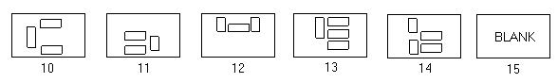

Step 1: Apply power to the logic designer by plug the AC adapter in to the 120 volt AC socket labeled J1.

Step 2: Connect leads wires from logic switches So thru S3 to terminals ABCD on the DM-4, with So to A, S1 to B, S2 to C, S3 to D. In the same manner, connect lead wires from terminals ABCD on the DM-4 to the logic indicators Lo thru L3 with Lo connect to A, L1 to B, L2 to C, L3 to D. Set logic switches So to S3 to zero (closed). Turn on the power switch. The DM-4 should display zero and LED’s L3 L2 L1 Lo are not lit. Set the logic switch S3 to zero and set S2 S1 So to “1” (switch open). The DM-4 should display “7” and the LED’s should display binary number 0111 which represents “7” in binary.

Step 3: Vary the settings of the four logic switches as indicated in the table on fill in these decimal numbers or symbols that are observed on the DM-4 display.

A C B A Output A C B A Output

0 | 0 | 0 | 0 |  |  | 1 | 0 | 0 | 1
0 | 0 | 0 | 1 |  |  | 1 | 0 | 1 | 0
0 | 0 | 1 | 1 |  |  | 1 | 0 | 1 | 1
0 | 1 | 0 | 0 |  |  | 1 | 1 | 0 | 0
0 | 1 | 0 | 0 |  |  | 1 | 1 | 0 | 1
0 | 1 | 0 | 1 |  |  | 1 | 1 | 1 | 1
1 | 1 | 1 | 0
0 | 1 | 1 | 1
1 | 0 | 0 | 0

EXPERIMENT # 2

LOGIC GATES

Objectives: To verify the truth table for some common TTL gates.

Material:

1-Breadboard or logic designer
1-7400 NAND Gate, 7402 NOR Gate, and 7404 Inverter
1-7408 AND Gate, 7432 OR Gate, 7486 XOR Gate

Procedure:

1. Connect the following circuits and complete the truth tables:

A  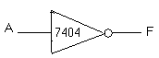 | F | 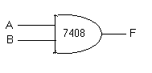 | A | B | F
0 |  |  | 0 | 0
1 |  |  | 0 | 1
 |  |  | 1 | 1
 |  |  | 1 | 0
 |  |  | 1 | 1

A | B | F | 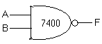 | A | B | F
0  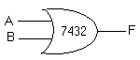 | 0 |  |  | 0 | 0
0 | 1 |  |  | 0 | 1
1 | 0 |  |  | 1 | 0
1 | 1 |  |  | 1 | 1

A | B | F | 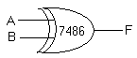 | A | B | F
0  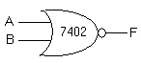 | 0 |  |  | 0 | 0
0 | 1 |  |  | 0 | 1
1 | 0 |  |  | 1 | 0
1 | 1 |  |  | 1 | 1

* Consult the data sheets for these devices in the APPENDIX of your text, IF YOU HAVE ANY, OR USE THE WEB for connection diagrams. Note which pin you want to connect to ground and which pin you want to connect to +5V to power device.

1. Demonstrate how the AND gate can be used as a “Digital Switch” by making the following connection.

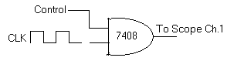
EXPERIMENT # 3

GATE EQUIVALENTS

Objectives: To verify that the five basic logic operations can be implemented by using just NAND gates or NOR gates.

Material needed:

- Pencil Box Logic Designer
- 7400 NAND Gate, 7402 NOR Gate

Procedure:

- Connect the 7400 circuits shown and identify each basic logic operation by the results of each truth table.

A  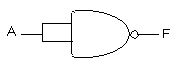 | F  Logic Operation = _____________
0
1

A  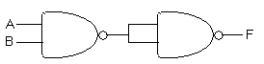 | B | F
0 | 0 | Logic Operation = ______________
0 | 1
1 | 0
1 | 1

A  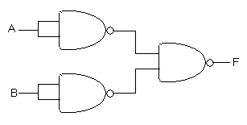 | B | F
0 | 0 | Logic Operation = _____________
0 | 1
1 | 0
1 | 1

A  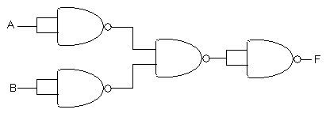 | B | F
0 | 0 | Logic Operation = _____________
0 | 1
1 | 0
1 | 1

- Connect the 7402 circuits shown and identify each basic logic operation by the results of each truth table.

A  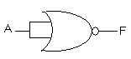 | F
0 | Logic Operation = _____________
1

A  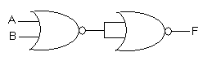 | B | F
0 | 0 | Logic Operation = _____________
0 | 1
1 | 0
1 | 1

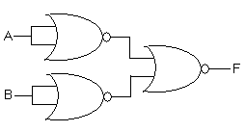
A | B | F
0 | 0 | Logic Operation = _____________
0 | 1
1 | 0
1 | 1

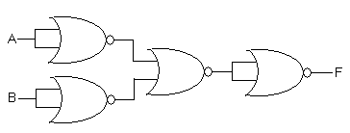
A | B | F
0 | 0 | Logic Operation = _____________
0 | 1
1 | 0
1 | 1

Questions:

  - Show how the XOR operation can be achieved using just NAND Gates.

  - As in #1 but just NOR gates.
EXPERIMENT # 4

COMBINATIONAL LOGIC NETWORKS

Objectives: 1) To compare the implementation of an unsimplified logic expression with that of the simplified logic expression.

  - To use Demorgan’s Laws to arrange the logic expression for NAND Gate implementation.

Equipment:

- Pencil Box Logic Designer
- 7410 Triple three input NAND gates
- 7400 Quad two input NAND gate

Background:

The two basic types of digital networks care called Combinational and Sequential networks. In the combinational network, the output depends on the values of the inputs at a particular instant of time. In the sequential network, the output depends on the previous values of inputs as well as the present values.

In this experiment, a truth table provides the basic for writing the unsimplified logic expression in minterm form. Using Demorgan’s Laws, this logic expression in written in a form for NAND gate implementation.

The logic expression can be simplified by using Boolean algebra postulates and identifies, or by using the Karnaugh Map.

Procedure:

- The truth table of table 1 gives the desired logic function. Reading the function in minterm form gives

A | B | C | F
0 | 0 | 0 | 0
0 | 0 | 1 | 0
0 | 1 | 0 | 1  
0 | 1 | 1 | 1
1 | 0 | 0 | 0
1 | 0 | 1 | 0
1 | 1 | 0 | 0
1 | 1 | 1 | 1

TABLE 1

Connect the logic diagram of Fig. 1. Apply the inputs given by the truth table and verify the function values.
PIN 7 → GROUND
PIN 14 → + 5V

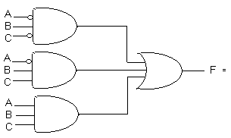
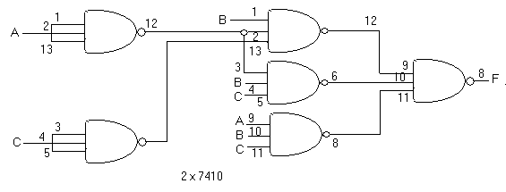

FIG.1

- By simplification:
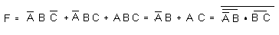

3. Connect the circuit in Fig. 2. Apply inputs and verify the truth table.
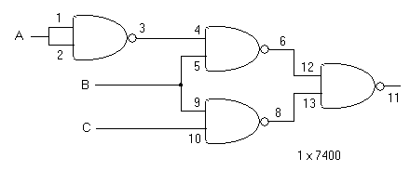
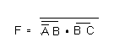
PIN 7 → GROUND
PIN 14 → + 5V

FIG. 2

Questions:

  - Prove the simplification by using the Karnaugh Map in procedure 2.

  - Show how the simplification in procedure 2 could be constructed by using only NOR Gate.

EXPERIMENT # 5

DIGITAL MULTIPLEXER - DATA SELECTOR

Objective: To study the digital multiplexer as a device to implement complex logic functions.

Material required:

1- Pencil Box Logic Designer
1- 74151 Multiplexer
1- 7404 Hex Inverter

Procedure:

    - Connect the 74151 8 to 1 multiplexer as shown below and fill in the F column of the truth table.
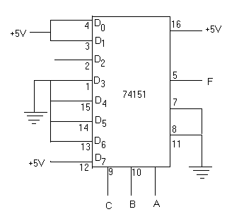

C | B | A | F
0 | 0 | 0
0 | 0 | 1
0 | 1 | 0
0 | 1 | 1
1 | 0 | 0
1 | 0 | 1
1 | 1 | 0
1 | 1 | 1

2. From the truth table the expression for F is:

F = _______________________

  - Determine what the Do-D₇ level should be to implement the truth table shown below. Hook up the circuit and verify the operation. Indicate the levels on the chip diagram.
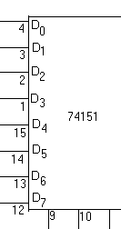
C | B | A | F
0 | 0 | 0 | 0
0 | 0 | 1 | 1
0 | 1 | 0 | 1
0 | 1 | 1 | 0
1 | 0 | 0 | 1
1 | 0 | 1 | 0
1 | 1 | 0 | 0
1 | 1 | 1 | 1

F= A 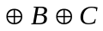

  - Using the following techniques to allow the 74151 to implement four variable expressions show that D₀ – D₇ levels would be to produce:

B | C | D | A | F
0 | 0 | 0 | 0 | 0  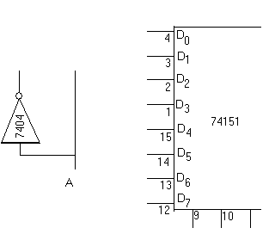
0 | 0 | 0 | 1 | 0
0 | 0 | 1 | 0 | 0
0 | 0 | 1 | 1 | 1
0 | 1 | 0 | 0 | 0
0 | 1 | 0 | 1 | 1
0 | 1 | 1 | 0 | 1
0 | 1 | 1 | 1 | 0
1 | 0 | 0 | 0 | 0
1 | 0 | 0 | 1 | 1
1 | 0 | 1 | 0 | 1
1 | 0 | 1 | 1 | 0
1 | 1 | 0 | 0 | 1
1 | 1 | 0 | 1 | 0
1 | 1 | 1 | 0 | 0
1 | 1 | 1 | 1 | 0

  - Indicate the levels on the chip diagram and hook up the circuit to verify the truth table for the expression.

Questions:

- Show the truth table and complete diagram to implement:
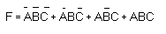
- As in question 1, but:

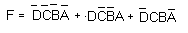
EXPERIMENT # 6

LATCHES

Objectives:
To examine the behavior of a NAND latch, a gated NAND latch, and a D latch.

Background:
The latch is a digital memory circuit that can retain its output state even after the input signals are removed.

Material Required.
1-breadboard or trainer
1-7400 Quad Dual Input TTL NAND Gate
1-7402 Quad Dual Input TTL NOR Gate
1-7475 Quad TTL D Latch
2- 1KΩ Resistors.

Procedures:

- Connect the 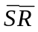NAND Latch and verify the truth table.
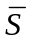 | 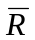 | Q | 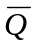
1 | 0 | 0 | 1
1 | 1 | 0 | 1
0 | 1 | 1 | 0
1 | 1 | 1 | 0
0 | 0 | 1 | 1
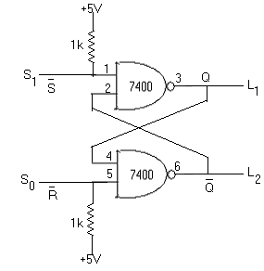
S | R | Q
1 | 0 | 1 | 0
0 | 0 | 1 | 0
0 | 1 | 0 | 1
0 | 0 | 0 | 1
1 | 1 | 0 | 0

- Connect the SR NOR Latch and verify its truth table.

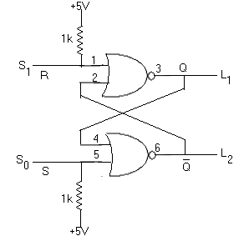

- Connect the Gates NAND Latch circuits and verify the truth table.

S | R | EN | Q | Q
0 | 1 | 1 | 0 | 1
0 | 0 | 1 | 0 | 1
1 | 0 | 1 | 1 | 0
0 | 0 | 1 | 1 | 0
1 | 1 | 1 | 1 | 1

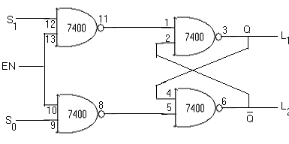

- Place the appropriate states on S, R and EN to make Q = 1 and Q + 0, or Q = 0 and Q = 1.

- Bring EN = 0 and notice how the S and R states can not affect the Q and Q states.

- Connect ¼ of the D latch IC.

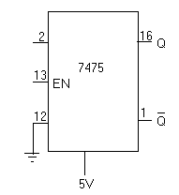

- With EN = 1 vary the state on D and notice how the output states follow.

- Bring the EN = 0 and notice how the output states aren’t affected by the S state anymore.

Question:

- With a circuit diagram show how NAND gates can be connected to make a D latch.

EXPERIMENT # 7

FLIP-FLOPS

Objectives:

To investigate the operation of:
- Positive-edge triggered D flip-flop
- Master-Slave level triggered JK flip-flop
- Positive-edge triggered SR flipflop

Material Required:

1-Breadboard or logic designer
1-7476 JK Flipflop
1-7404 Hex Inverter Gate
1-7474 D Flipflop
1-74—NAND Gate

Procedures:

- Connect one-half of the 7474chip as shown below:

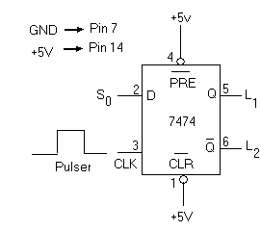

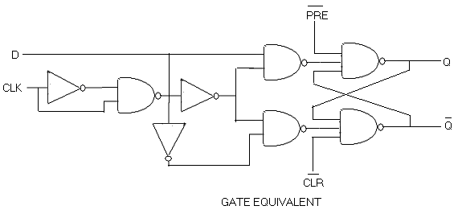

2. Verify that the D input is transferred to the Q on the positive edge of the clock (CLK) by
completing the truth table shown below

Transition from low to high and staying high. (keep finger on button).

Transition from high to low and stay in low condition.
D | C | Q
0
1
1
0
0

3. Connect one-half of the 7476 ship as shown:

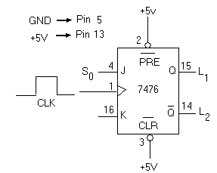
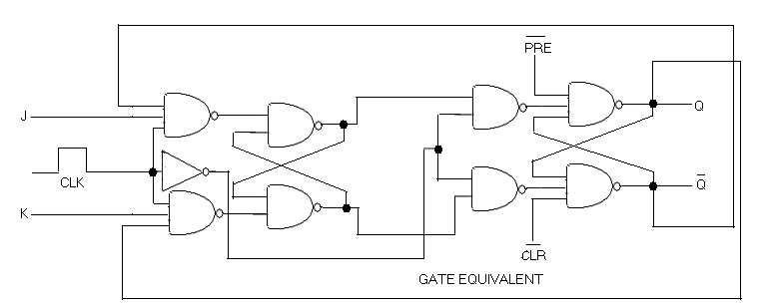

4. Complete the truth table and notice the JK inputs affect the outputs only when CLK drops from high (1) to low (0)

J | K | C | Q
1 | 0 | 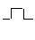
0 | 1
0 | 0
1 | 1
1 | 1
1 | 1

5. Connect the gate equivalent of the positive-edge triggered SR flip-flop as shown:

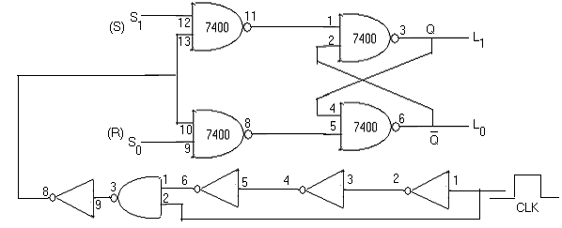

6. Verify that the flip-flop “works” on the positive edge only and not when CLK is held high.

Questions:

- Explain why L₂ and L₃ behaved the way they did in procedure 6.
- Show the gate equivalent for a master-slave D Flip-flop.
- Show the equivalent for a positive-edge triggered JK flip-flop.
- Show the gate equivalent for a data look-out JK flip-flop.
EXPERIMENT # 8

FOUR-BIT RIPPLE COUNTER

Objective:
To study the 7493 integrated counter

Material required:
1-breadboard or logic designer
1- 7404 Inverter
1- 7493 Integrated counter.

Theory:
The 7493 is a four-bit ripple type binary counter. It consists of four flip-flops which are connected as shown in the figure below. In order to function as a four-bit counter, 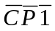must be externally connected to Q_{A}. If both the master reset pins MR₁ and MR₂ are raised high, the four-bit flip-flops are reset to zero.

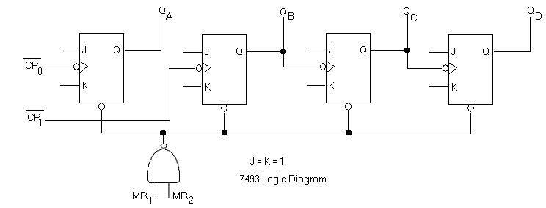

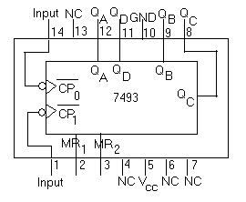

Procedure:
- Connect the MOD-16 counter shown in fig.2 below:

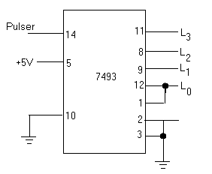
Fig.2, MOD-16 Connection

- Operate the pulser to verify that the count goes from zero (0000) to fifteen (1111).
- Replace the pulser with the clock and use a dual trace oscilloscope to observe the waveforms at the clock and the counter outputs. Sketch a timing diagram.
- Replace the clock with the pulser and make the circuit modification shown in fig.3 below to convert the counter to a BCD (MOD-10 decade) counter.

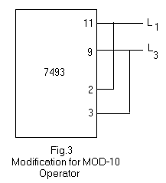
- Operate the pulser to verify that the count goes from zero (0000) to nine (1001).
- Replace the pulser with the clock and sketch the timing diagram as in step 3.
- Connect the inverter (7404) between each output and its indicator.
- Replace the clock with the pulser and verify that the operation is now a decade down counter.

Questions:

- Show how a 7493 and other gates as needed could be connected to produce a MOD 13 down counter.
- As in #2 except a MOD 6 up counter.
- Show how a 7493 can be connected to operate as a ÷ 12 frequency divider.
EXPERIMENT #9

555 TIMER

Objective:

To construct an astable multivibrator using the 555 timer.

Parts Needed:

1- 555 Timer chip
1- 1μF Capacitor
1- .01μF Capacitor
1- 1KΩ Resistor
1- 100KΩ Resistor
1- 1MΩ Resistor
1- LED

Theory:

An astable multivibrator is a switching circuit having two different states neither of which is stable. As a result, the circuit continuously switches back and forth between these two unstable states. In other words, the circuit oscillates and the output is a periodic rectangular waveform. Such a circuit can be used in numerous applications. For instance, such an oscillator might be used as a system clock.

Procedure:

- Evaluate the oscillator shown un Fig. 1 and determine the following:

PW: SW:

F: % Duty Cycle:

R₁ = 100KΩ
R₂ = 1MΩ
C = 1μF
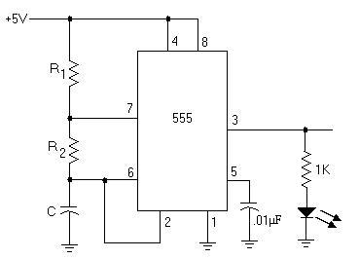

FIG. 1

- Construct the circuit shown in Fig. 1 and note what you observe.

III.

AC Circuits

IV.

Electronics I – Devices

EXPERIMENT #1

JUNCTION—DIODE CHARACTERISTICS

Parts Required:

1- 1N914 DIODE
1- 47Ω / ½W RESISTOR
1- 250 Ω / 2W RESISTOR
1- 1Ok Ω POTENTIOMETER

Procedure:

- Connect the circuit shown and complete table 1.

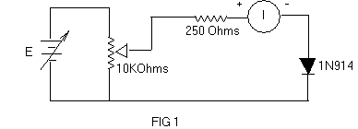

V_{D}(V) I_{D}(mA) V_{D}(V) I_{D}(mA)

.10 .55
.20 .60
.30 .65
.40 .70
.45 .75
.50 .80

TABLE 1

2. Observe the blocking action of the diode when reverse biased.
V_{D} = -20v I_{D} = ________

3. Plot the volt-ampere characteristics of the diode using the data in table 1.

4. Determine the operating point for the diode in the circuit shown in fig 2. by plotting the load line on the graph.

V_{D} = _______ I_{D} = ________

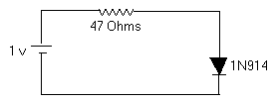

5. Measure the operating point for the circuit in fig.2 and compare your results to step 4.
V_{D} = _______ I_{D} = ________

* use I_{D} = V_{R}/R

EXPERIMENT #2

CLIPPER/CLAMPER
Parts Required:
1- 1N914 Diode;
1- 1N2070 Diode
1- 100 kΩ Resistor
1- l0kΩ Resistor
1- 0.1μF Capacitor

Procedure:

1. Connect the positive peak shunt clipper circuit shown and superimpose the output waveform on the input waveform and study the result.

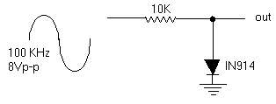

2. Replace the lN914 switching diode with the 1N2070 rectifier diode and study the result.

3. Change the input to a square-wave and repeat steps 1 and 2

4. Lower the frequency to 1 KHz and repeat steps 1, 2, and 3.

5. Change the circuit to a positive peak series clipper and repeat step 1-4.

6. Connect the negative damper shown and superimpose the output waveform on the input waveform and study the result

.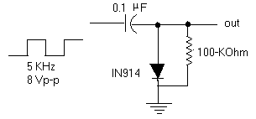

7. Change the frequency of the input and study the result.
8. Replace the 100 KΩ-resistor with the l0 KΩ-resistor and repeat steps 6 and 7.

Questions:
1. What conclusions can be drawn from your observations in step 1- 4?
2. As in question #1 but for step 5?
3. As in question #1 but for step 6-8?

EXPERIMENT #3

ZENER DIODE REGULATOR

Materials Required:
1- 1ZM12T5 Zener Diode
1- lKΩ/ 2W; l0KΩ/ 2W; l00Ω/.5W Resistors
1- l0KΩ Potentiometer;
1- SPST Switch

Procedure:

1. Connect the circuit shown in Fig.1 (Connect Zener diode properly)

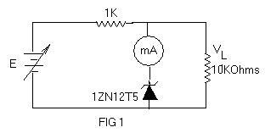
V1(V) | VL(V) | Iz(ma)
11
13
15
17
19
21
23
TABLE 1

2. To observe the “line regulation “of the regulator, adjust V₁ and complete table 1.

3. To observe the “load regulation “of the regulator, replace R_{L} with a l0KΩ Pot, and set V₁ = 20V and complete table 2.

R_{L} | V_{L}(V) | I_{z}(mA) |  | R_{L} | V_{L}(V) | I_{z}(mA)
9.5K |  |  |  | 5K
9K |  |  |  | 4.5K
8.5K |  |  |  | 4K
8K |  |  |  | 3.5K
7.5K |  |  |  | 3K
7K |  |  |  | 2K
6.5K |  |  |  | 2.K
6K |  |  |  | 1.5K
5.5K |  |  | TABLE 2 | 0.5K

4. Connect the circuit shown in Fig.2. Frequency set at 1KHZ

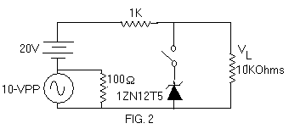

5. Measure ripple voltage across RL.

Ripple Voltage = _______________

6. Close the switch and measure ripple voltage across RL
Ripple Voltage = _______________

7. Make a graph of information contained in table 1, and table 2

Questions:
1. Explain in detail why V_{L} acted as it did in table 2.
2. Why did the Zener diode act to reduce the ripple in step 6?
3. Why exactly did the presence of the milliammeter in the Zener branch reduce the effectiveness of the diode?
4. If the l0-KΩ load resistor opened in the circuit of Fig.2. How much Zener dissipation would be developed?

EXPERIMENT #4

BRIDGE POWER SUPPLY

Parts Required:

1- 26.8VCT Transformer
4- 1N5625 Rectifier Diodes
1- 500Ω/5W Resistor
2- 100μF/50V Filter Capacitors
1- Fused Line Cord
1- SPST Switch
1- l00Ω/1W Resistor

Procedure:

1. Check each diode with the DMM to see if it’s good.

2. Connect the circuit shown, but before applying power, very carefully check your wiring.

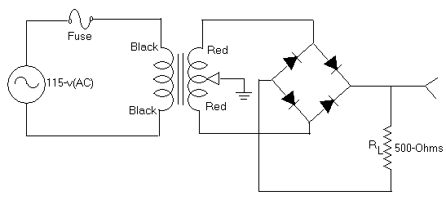

3. Plug in the fused line cord.

4. Turn on the power switch (* Caution: R_{L} gets hot). Measure the DC voltage across R_{L} with the DMM and measure the peak to peak ripple voltage across R_{L} with the scope (input = AC). Record these values in table 1. Notice the shape of the ripple voltage also.

5. Open the power switch. Add a 100/LF filter capacitor across P1 (see figure for correct polarity). Repeat step 4.

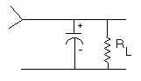

6. Open the power switch. Add an additional 100μF filter capacitor across R_{L.} Repeat step 4.

7. Open the power switch. Connect a 100Ω resistor between the filter capacitors to make a Pi filter (see figure). Repeat step 4.

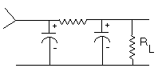

8. Open power switch. Remove any one of the diodes form the bridge (leave an open circuit in its place).
9. Repeat step 4.

10. Open the power switch. Remove the 100Ω resistor from the circuit and put a short circuit in its place. Repeat step 4.

11. Open the power switch. Remove one of the filter capacitor form the circuit. Repeat step 4.

12. Open the power switch. Remove the remaining filter capacitor form the circuit. Repeat step 4.

Step | Vdc | P-P | Step | Vdc | P-P
 | 4 | 12
 | 5 | 11
 | 6 | 10
 | 7 | 9

TABLE 1. Voltage across R_{L}.

EXPERIMENT #5

TRANSISTOR FAMILIARIZATION

While working in electronics you’ll encounter many transistors. Transistors are composed primarily of either silicon (Si) or germanium (Ge).
As is the case with solid, state diodes, the transistors that are germanium will indicate lower measured resistance values than those that are silicon.
Each transistor is composed of three sections, either PNP or NPN as shown in FIG. 1.

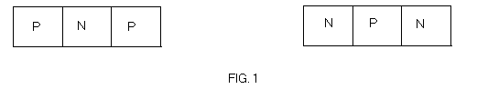

Notice that each end section is doped similarly while the center section is doped opposite to the ends. As with diodes the letters P and N indicate the types of dopants that are used in each section (P = acceptors, N = donors). Also, like diodes, transistors are monocrystalline. That is, each section is a continuation of the growth of’ the preceding section.

Each section has a wire attached; the middle section is called the base.

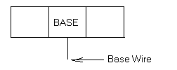

Even though the end sections are doped with the same kind of dopant, the emitter section is doped heavier than the other end section, which is called the collector section.

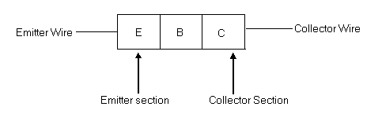

Notice that the transistor has two PN junctions. They are referred to as the emitter junction and collector, junction respectively.

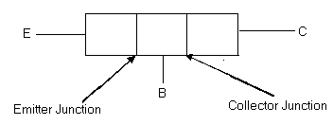

For the PNP type transistor: if a battery is connected with the negative lead touching the base wire and the positive lead touching the emitter and collector wires both junctions become forward biased. The reverse polarity would be needed to forward bias both junctions of the NPN transistor.

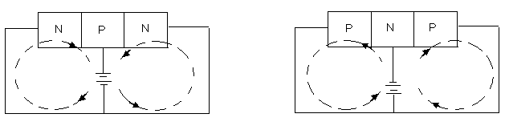

Equipment

1- L_{V} power supply
1- VOM
1- 10mA milliammeter
1- 200μA microammeter
1- 470KΩ resistor
1- 2N404 transistor

1- 2N1011 transistor
1- 2N1086 transistor
1- 2N1413 transistor
1- 2N3569 transistor
1- 2N4000 transistor
1- 2N6541 transistor

Determining the Polarity of Ohmmeter Leads

Adjust the VOM to the Rx1K ohmmeter range and set the milliammeter to the 10 mA range.

Connect the ohmmeter leads across the milliammeter so that the milliammeter pointer moves up scale (moves to the right).

With this connection, the ohmmeter lead connected to the negative (black) post on the milliammeter is the negative ohmmeter lead and the other is the positive ohmmeter lead.

NPN? or PNP?

The 2N404 transistor is packaged in the TO – 5 style metal case.
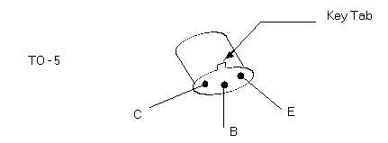

The 2N404 is a PNP transistor. You can easily verify this if you connect the negative ohmmeter lead (always use the Rx1K range) to the base wire of the transistor and the positive ohmmeter lead to the emitter wire, a low (approximately 1KΩ - 2KΩ) resistance should be indicated. Reverse the ohmmeter leads and note the very high resistance indicated.
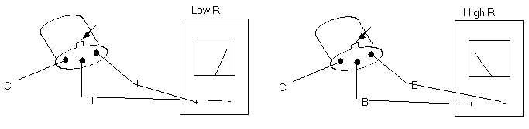

Now verify that the 2N1086 is a NPN transistor.

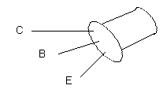

Both the 2N404 and the 2N1086 are germanium transistors.

Verify that the 2N6541 transistor is a NPN transistor.

Notice that the resistance values indicated are higher than before. This is so because the 2N6541 transistor is a silicon transistor.

Determine if the 2N1413 transistor is NPN or not, and silicon or not. The 2N1413 is a (NPN) (PNP) (Si) (Ge) transistor.

The 2N3569 transistor is packaged in the TO - 98 case.
The 2N3569 transistor is a (NPN) (PNP) (Si) (Ge) transistor.

The 2N4400 transistor is packaged in the TO - 106 case.
The 2N4400 transistor is a (NPN) (PNP) (Si) (Ge) transistor.

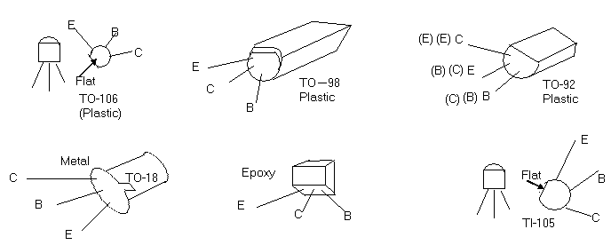

The transistors that you have been checking have been some of the physically small “milliwatt” types. The 2N1011 transistor is classified as a “power” transistor because of its ability to safely pass higher currents and dissipate more power than the milliwatt type transistor. The diamond shaped case of the 2N1011 transistor is the TO - 3 style.The black finned, aluminum stricture that the case is bolted to is called a “heat sink”, “heat exchanger”, or just “cooler”.
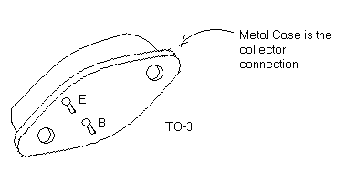

Verify that the 2N1011 transistor is a PNP transistor. The 2N1011 is germanium, but notice that the measured resistances are lower than those encountered with the milliwatt germanium transistors. Silicon power transistors also indicate lower resistances than the silicon milliwatt types. This is so because power transistors have much larger junction areas and employ higher doping.

Shown below are some additional case styles used with power transistors.

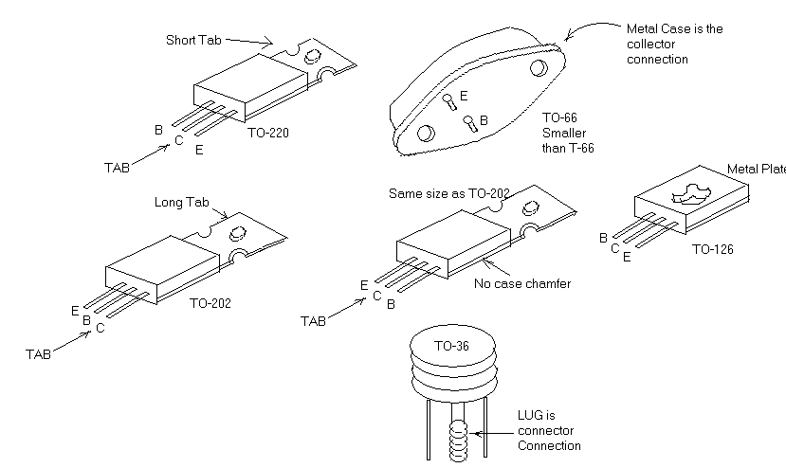

Transistor Symbols

The symbols used for power transistors on circuit diagrams are the same as those used for the milliwatt types, but a distinction is made between NPN and PNP.

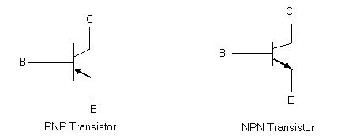

Notice that the emitter always has the arrow head and it points out for the NPN transistor but points in for the PNP transistor. The B, C, E letters are not part of the transistor symbols and as such are seldom included on circuit diagrams.

Transistors Biasing

One of the most common biasing arrangements employs a single battery or power supply.

Transistors are normally biased so that the emitter junction is forward biased and the collector junction is reverse biased. In order to achieve this, a resistor voltage divider is used with the power supply or battery.

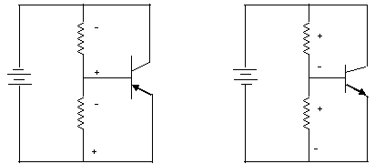

Notice that the voltage drop polarities across the upper resistors are for proper reverse biasing the collector junctions, while the lower resistor produce forward bias polarities for the emitter junctions.

Sometimes the lower resistors are not used and the forward biased emitter junctions act as the lower elements in the voltage divider.

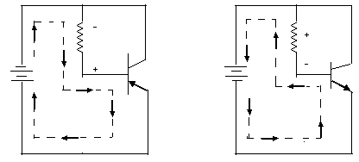

One would expect because the collector junction is reversed biased that the collector current would be very small, “transistor action”, the collector flow is usually quite large compared to the base current.

The transistor acts like a valve for electrons flowing between the collector and the emitter. A small base current, which acts like a control current, produces a much larger (sometimes hundreds of times larger) collector flow. The flow in the emitter is the sum of the base and collector flows.

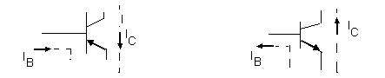

Using the 2N404 transistor connect the circuit shown below.

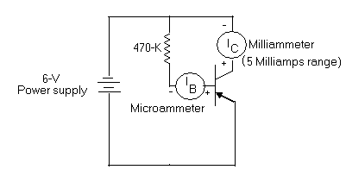

Notice that the collector current (Ic) is far from zero and is in fact much larger than the current flowing in the ‘case lead.

Questions

1. Operationally, what would be the consequence of making the base section of a transistor much. too wide?

2. Why do you suppose the maximum reverse voltage rating for the emitter junction of a transistor is much lower than that of the collector junction?

3. Why do you suppose the collector junction gets hotter than the emitter junction in a properly biased transistor?

4. Do you think that two diodes could be wired together as shown below to make a transistor? Explain.

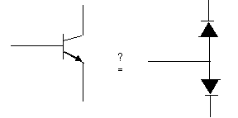

EXPERIMENT #6

DC CHARACTERISTICS OF A TRANSISTOR

Objectives:

To investigate relationships between base to emitter voltage, base current, collector to emitter voltage, and collector current for a milliwatt style silicon transistor

Parts Required:

1- DC Power supply
1- DMM
1- DC Milliammeter
1- DC Microammeter
1- 2N3569 Transistor
1- SPST switch
Resistors: l00KΩ; 500Ω Pot; 2.5K Ω Pot

Procedure:

- Connect the circuit shown in FIG l.

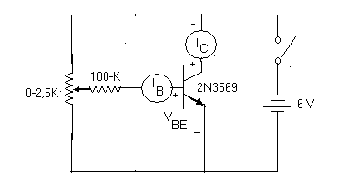

2. Close the switch and adjust the base current to the values shown in Table 1.

VBE (V)
IB (μA) | 0 | 5 | 10 | 15 | 20 | 25 | 30 | 35 | 40
Ic (mA)

TABLE 1
3. Modify the circuit to that shown in Fig.2.

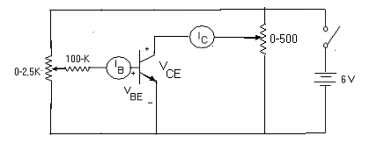

4. Close the switch and adjust the base current to 10 microamps. Adjust the collector to emitter voltage to the values shown in table 2 and record the collector currents. Repeat for the other base currents shown in Table 2.

Vce (Volts)
TABLE 2
Collector Currents (mA)
IB (μA) | 0 | 1 | 2 | 3 | 4 | 5
10
20
30
40

5. Make three graphs of the data in table 1.
Examples:

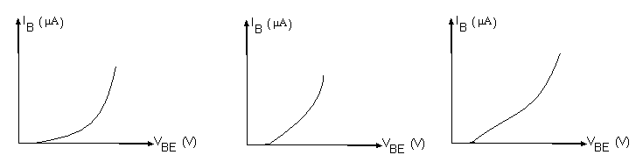

- Make a family type graph of the data in table 2. Title the graph “Step 4”.
Example:
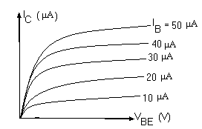

7. On your graph of step 4 draw the collector DC load lines for resistors of 470Ω, 1KΩ, and 2.2KΩ. Use Vcc = 5V.

8. Indicate the operating points on your load lines when I_{B} = 30μA.

Question:

1. Which has the greater effect on Ic, changing the I_{B} values or changing the Vce Values?
EXPERIMENT #7

TRANSISTOR BETA AND COLLECTOR CURRENT CEILINGS

Part A - Transistor Beta

The Beta of a transistor is basically an indication of how sensitive the collector current (the “controlled” current) is to the base current (the “controlling” current). A high Beta transistor is very sensitive in this respect.

The Beta value of a transistor is determined by effecting a change in the base current and with no external resistor in the collector circuit noting the collector current change. The Beta value is the ratio of these changes.

Beta (B) = ΔIc/ΔIB

The value may vary from around 30 to 500 depending on the transistor. The manufacturer of the transistor will usually list MINIMUM, MAXIMUM, and TYPICAL values of Beta for the transistor. Some transistors are manufactured to exhibit high Beta values, and some low. For example, the 2N3569 transistor is designed to exhibit a higher Beta value than the 2N4400.

The collector characteristics graphs show the difference between two transistors of differing Beta values. The characteristics for the higher Beta transistor are more “open” and higher collector currents are produced for given base currents compared to the lower Beta transistor (FIG. 1).
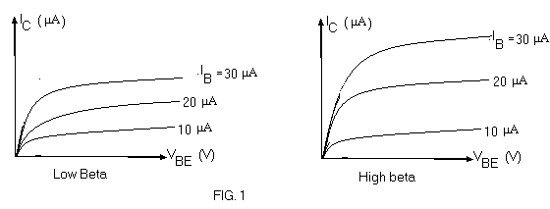

Equipment:

1- L_{V} power supply
1- VTVM
1- VOM
1 - l0mA milliammeter
2 - 2N3569
2 - 2N4400 transistor
1 - 10K potentiometer
1 - 33K resistor
1 - 4.7K resistor
1 - 2.2K resistor
1 - 1K transistors
1 - SPST switch

Part B - Collector Current Ceilings

The load line analysis shows us that the collector current ceiling (the maximum possible collector current) should be essentially equal to the collector supply voltage (V_{CC}) divided by the resistance of the resistor in the collector circuit. This means the lower the resistor __ the higher the collector current ceiling, and of course with zero resistance there is no ceiling.
(FIG. 2)

The analysis also shows that as the collector resistor is decreased more base current is needed to get to the ceiling.

Notice that the value of V_{CE} at the ceiling is slightly larger for lower collector resistors.
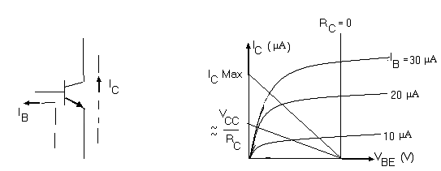

FIG. 2

Procedure

1. Use either one of the 2N3569 transistors and connect the circuit shown below, set R1 to zero ohms. Use the VTVM to measure VCE and VEE voltages.
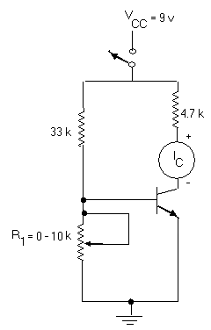

2. Close the power switch and increase R1 until the collector current stops increasing.

3. Record the data in the table on the next page.

4. Open the power switch and replace the 4.7K resistor with the 2.2K resistor.

5. Repeat steps 2 – 3.

6. Open the power switch and replace the 2.2K resistor with the 1K resistor.

7. Repeat steps 2 - 3.

8. Open the power switch, replace the 2N3569 transistor with either of the 2N4400 transistors, replace the 1K resistor with the 4.7K resistor and set R1 to zero ohms.

9. Repeat steps 2 - 7.

2N3569 2N4400

Rc Ω | Ic  (mA) | VBE (v) | VBE  (v) |  | Rc Ω | Ic  (mA) | VBE (v) | VBE  (v)
4.7K |  |  |  |  | 4.7K
2.2K |  |  |  |  | 2.2K
1K |  |  |  |  | 1K

Questions:

1. What conclusions can you draw from the results of the steps in Part A and Part B?
EXPERIMENT #8

VOLTAGE DIVIDER BIASED TRANSISTOR

Parts Rrequired:

1 - 2N3904
1- 470Ω; 2.7K Ω ; 4.7K Ω ; 33K Ω

Procedure:

1. Connect the circuit voltage divider biased transistor shown and measure:

V_{B} = _________ Volts
V_{E} = _________ Volts
V_{C} = _________ Volts

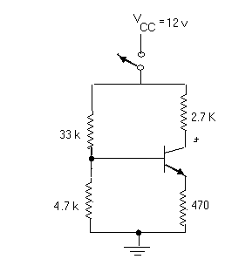

2. Using only the power supply voltage and the resistor values analyze the circuit.

I_{C} = _________ A

V_{E} = _________ Volts

V_{B} = _________ Volts

V_{C} = _________ Volts

EXPERIMENT #9

COMMON EMI7TER AMPLIFIER

Parts Required:

1- 2N3569 Transistor
1- lKΩ Pot
1- 470Ω, 2.2KΩl, 22KΩ, (2)4.7KΩ Resistors
1- l00μF/6V, 50μF/25V, 25μF/6 Capacitors

Procedure:

1. Construct the circuit shown below with Vs = 0 volts. Measure the DC voltage form Base, Emitter, and Collector to ground and record them on the diagram shown.

2. Adjust the input level (Vs) for an output level of Vout = 1 volt and measure Vs.

Vs = ________volts; Voltage Gain = __________

3. Use dual trace oscilloscope to verify that Vout is l80° out of phase with Vs.

4. Open the emitter capacitor and repeat step 2 and 3.

Vs = ________volts; Voltage Gain = __________

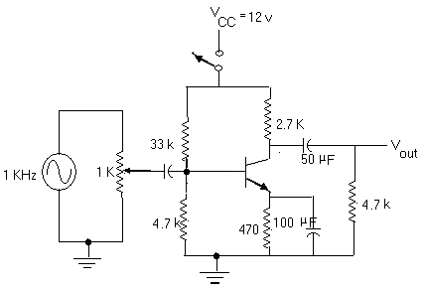
EXPERIMENT #10

JPET AMPLIFIER

Parts Required:

1 - 2N5458 JFET
1 - 4.7KΩ, 1MΩ Resistors
1 - 5KΩ Pot
1 - 50mF/16V, .02mF Capacitors

Procedure:

1. Connect the circuit shown (switch open)

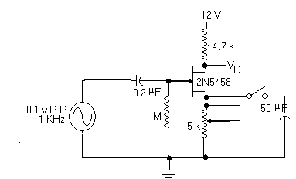

2. Adjust the 5K pot for a drain to ground voltage of +6VDC.

3. Record voltage across the pot ______ VDC.

4. Observe output signal at the drain ______ V_{P-P}

5. Close the switch and repeat step 4 ______ V_{P-P}

Questions:

1. Explain the results of step 5.

2. Compute the voltage gains in steps 4 and 5. A_{V} = V_{D} / .1
EXPERIMENT #11

PUSH-PULL CLASS B AMPLIFIER

Material Required:

Transistors: 2- 2N3904;, 1- 2N3906
Diode: 2- 1N914
Capacitors: 1- 100 μF/16V, 25 μF/16V
Resistors: 1- 2.2K Ω, 1.5K Ω, 1K Ω, 220 Ω, 22 Ω, 5K Ω Potentiometer

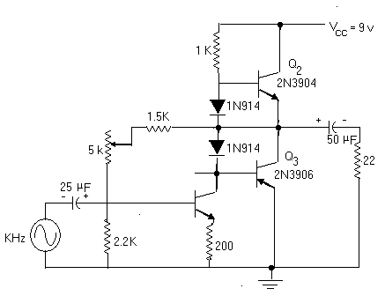

Procedure:

- Connect the circuit shown but DO NOT connect power (VCC).

- Instructor check circuit _________________.

- Apply 9 volt power with V_{S} = 0 VAC

- Adjust Potentiometer for VE2 = VE3 = +4.5 volts.

- Monitor V_{S} and V_{O} with scope and adjust V_{S} for V_{O} = 3V_{P-P}

- Notice phase relation between V_{S} and V_{O.}

- Compute voltage gain A_{V} = __________________

Compute output power P_{L} = __________________W.

- Compare V_{O} with the signal voltage at the collector of Q1 voltage gain of the Q2 – Q3 power stage is ____________________.

- Short out one of the diodes and compare V_{O} with V_{S.}

Question:

- What is the distortion in step 9 called and what causes it?

V.

Electronics II
Operational Amplifiers

EXPERIMENT #1

CLASS A - COMMON EMITTER POWER AMPLIFIER
μ
Parts Required:

Resistors : 1- 470Ω, 560Ω, 5KΩ Pot, 4- 1KΩ
Capacitors: 1- 100μF, 2- 25 μF
Transistor: 2N3904 NPN Silicon.

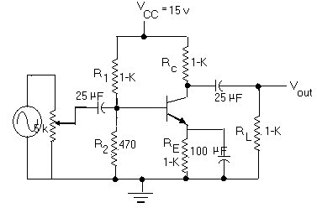

Measured
R₁
R₂
R_{C}
R_{L}

Table 1

FIG. 1

Procedure:

1. Measure and record all the fixed resistor values in Table 1.

2. Wire the circuit in Fig.1 with Vi = O_{V;} R_{E} = 1KΩ
3. Measure and record V_{B}, V_{E}, V_{CQ} and V_{CEQ} corresponding calculated voltage values assuming V_{BE} = 0.7_{V} in Table 2. Also, list percentage error for each voltage.

 |  | Measured | Calculated | % |  | Measured | Calculated |  | %
V_{B}
V_{E},
V_{CQ}

V_{CEQ}

4. Apply Vi_{P-P} = 50mv at 5KHz and compare output and input voltage form observation on oscilloscope.
5. Increase input voltage until clipping is observed and record the input and output peak to peak voltage in Table 3. Notice the polarity where clipping occurs first.

R_{E} | V_{InP-P} | A_{V} | P_{in} | Pout | A_{P} | ή
1K
560

Table 3

6. Repeat step 3, 4, and 5 with R_{E} = 560Ω.

7. Calculate the voltage gain, input power, output power, power gain, and efficiency and record these values in Table 3 f or the two different values of R_{E.}

8. Draw the DC and AC load line f or the two different values of R_{E.}

EXPERIMENT #2

FREQUENCY EFFECTS

Objective: To measure the critical frequencies of a CE amplifier.

Parts Required:

Resistors: lKΩ, 5.6k Ω, l0KΩ, 15KΩ, 100KΩ, 5K Ω Pot.
Capacitors: 3- 25 μF/25v, l- l00pF/25v.
Transistor: 2N3904.

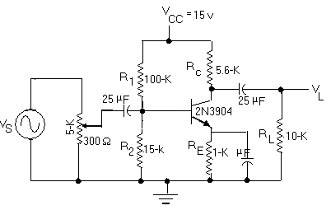

Procedure:

1. Assemble the circuit in Fig.l with vs = Ov.

2. Measure and record V_{B}, V_{E} and V_{V} dc voltages.

V_{B} = ________ V, V_{E} = ________ V, V_{C} = ________ V

3. Set R_{S} to 300Ω and adjust vs so that vin = 50mv at 10KHz. Determine the voltage gain
Av ‘= vo/vin and Av’=vo/vs from measurements of vs, vin and vo on an oscilloscope.

A_{V} = ________ A_{V} = ________

4. Reduce frequency while keeping vs constant until Vo = .707 of Vo at 10KHz. This corresponds to f1 of the frequency response of the amplifier. Record f1.

fl = _____________Hz

5. Calculate fl from circuit values and determine the dominant value (assume β = 100)

flc = _____________Hz

6. Determine f2 by measuring the upper frequency when Vo = .707 of Vo at 10KHz. (Keep vs constant)

f2 = _____________Hz

7. Place a l00pF capacitor between collector and base and repeat step 6.

f2‘ = _____________Hz

8. Place the l00pF capacitor between base and ground and repeat step 6.

f2’’ = _____________Hz

9. Calculate the dominant values for the three conditions.

f2c = _______ f2c’ = ________ f2c’’ = ________

10. Compare the measured and calculated frequency values, and explain any discrepancy. Show calculations for steps 5 and 9.
EXPERIMENT # 3

THE 741 OPERATIONAL AMPLIFIER

The 741 Operational Amplifier (Op Amp) is an integrated circuit amplifier that employs internal frequency compensation and is designed for DC and low frequency (below 1Mhz) operation. Like other Op Amps, the 741 requires a bi—polar power supply, i.e. a DC power supply with three leads: one positive, one negative, and one common (ground).
The 741 has an output “offset” null provision. Output offset refers to the condition where the DC output voltage of the Op Amp is not zero when both Op Amp inputs are at zero VDC. The data sheet is attached in the last page of this lab.
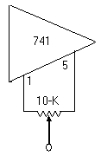Optional output offset null circuit.

Materials Required:

1- 741 Op Amp.
1- DMM/AC VTVM
1- 10012, lOkfl Potentiometers.
1— lkfl, 3—lOkfl, 1— 100k12, 1—lMf2.

Procedure:

1. Connect the non—inverting amplifier shown in Fig.l.

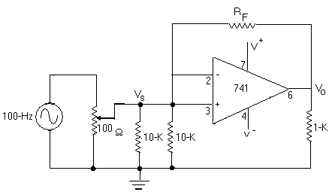

Non-Inverting Amplifier Employing Negative Feedback for Voltage Gain Control.
Voltage Gain = V_{o}/V_{s} ~1 + R_{F}/R_{S}

- Collect data and complete Table 1.

V_{S} (vac) | RF (Ohms) | V_{O} (vac) | 1+RF/RS | V_{O}/V_{S}
.01 | 1M |  | 101
.1 | 100K |  | 11
1 | 10K |  | 2
TABLE 1

3. Change the circuit to that of the inverting amplifier as shown in Fig-.2
• I
4. Collect data and complete Table 2.

V_{S} (vac) | RF (Ohms) | V_{O} (vac) | V_{O}/V_{S} | RF/RS
.01 | 1M |  |  | 100
.1 | 100K |  |  | 10
1 | 10K |  |  | 1
TABLE 2

5. With RF = 1MΩ maintain Vs = 20 mvac ( -32dB), measure V_{O} from 20Hz to 20KHz and graph dB voltage gain as a function of frequency on four-cycle semi-log graph paper.

6. Change RF to 100KΩ and repeat step 6, except maintain Vs =.2 vac (-12dB). Put both curves on the same sheet of graph paper.

7. Adjust Vs=0 vac. Measure DC output voltage at pin 6. Vo = ______ VDC.

8. Change RF back to lMΩ and repeat step 7. V_{O} = _______VDC.

9. With RF = 11MΩ connect the offset null circuit.

10. Adjust the offset null control over its entire range and observe the effect on Vo (VDC).

11. Adjust the offset null control for V_{O} = 0 VDC.

12. Remove the RF resistor and observe the effect on V_{O}.

13. Adjust the offset null control over its entire range and observe the effect on V_{O} . Can you adjust for V_{O} = 0 VDC?

Questions:

1) What undesirable effect on the operation of an Op Amp as an AC amplifier would be produced if the output exhibits an offset DC voltage?

2) The circuits connected in this experiment were all of the single ended input type. Show how the amplifier would be connected as a differential amplifier with maximum common mode rejection.
Type 741

Typical specifications for ±15-volt supply.

Gain ………………………………………. | 200.000 |  | (50,000 minimum)
Input Offset Voltage ……………………… | 1.0 | mV | (5.0 mV maximum)
Input Offset Current ……………………… | 20 | nA | (200 nA maximum)
Input Bias Current ………………………... | 80 | nA | (500 nA maximum)
Output Resistance ………………………... | 75 | ohms
Common-Mode Rejection ……………….. | 90 | dB | (70 dB minimum)
Slew Rate ………………………………… | 0.5 | V/μs

Remarks

  - Internally compensated. Requires no external frequency-compensation components.
  - Output short-circuit protected. Output current limited to 25mA.
  - Differential input voltage: ±30-volts maximum.
  - Provision for output offset null.

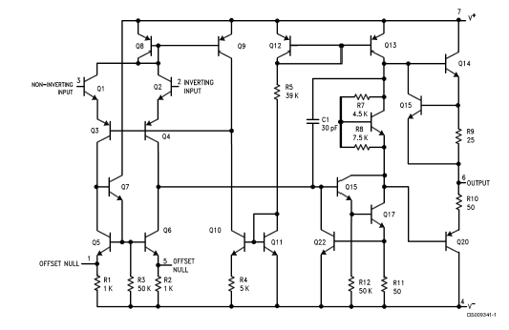
Equivalent Circuit for 741 type

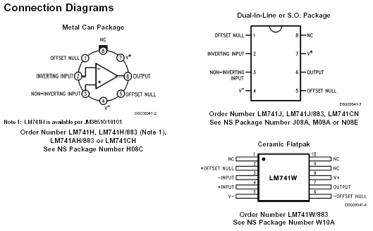
Connection Diagram

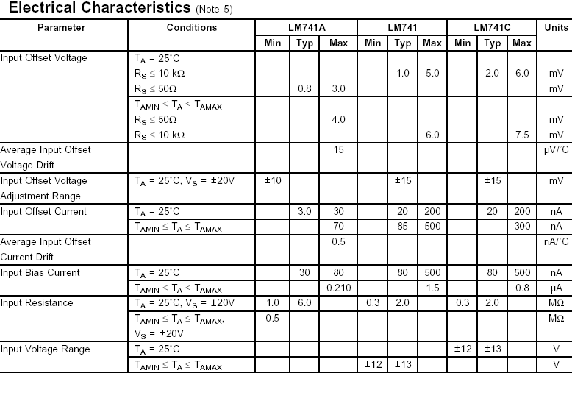

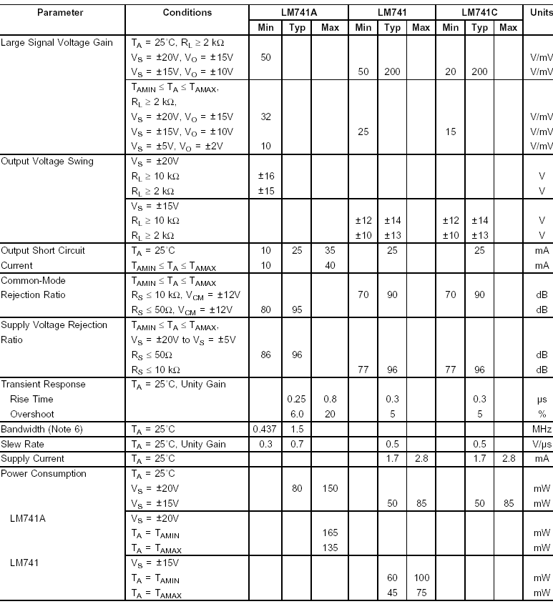

Electrical Specifications for an OP-AMP 741
As per Data Sheet
Supplied by the manufacturer

EXPERIMENT #4

IC DIFFERENTIAL AMPLIFIER

The differential amplifier is a two-input amplifier that allows subtraction of two voltages, or as a special case, the cancellation of a signal common to the two inputs.

An example of a situation that requires a differential amplifier is the amplifying of the very small EKG (ECG, Electrocardiogram) signals developed by the heart and measure between two places on the outside of the body, such as between the arms, one leg is used as a common tit point (ground).

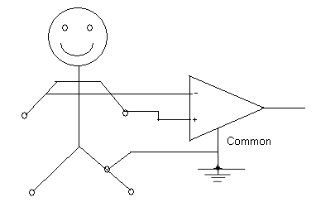

The voltage from arm to arm is the difference between the left arm to leg voltage and the right arm to leg voltage.

Because the body is surrounded by sources of electromagnetic interference such as AC power lines, a considerable amount of 60Kz AC appears on the body along with the tiny EKG signal voltages. However, the induced 60Kz voltage across the arm to leg connections are in phase, i.e. common mode voltage and should cancel out it a differential amplifier is used.

The ability of a differentia; amplifier to reject common mode voltages at its inputs compared to how well it amplifies the difference voltage is most important. The specifications that indicates this ability is the “common mode rejection ratio.”

Common mode rejection ratio = CMRR

CMRR = 20 Log (A_{D}/A_{C}) dB

Where A_{D} = differential voltage gain
A_{C} = common mode voltage gain

Controlling the amount of differential voltage gain while maintaining high common mode rejection, requires adjustment of resistors at both inputs of the amplifier.

So in the ideal case where R₂ = R₄
R₁ R₃

A_{C} = 0, A_{D} = R₂
R₁
If V_{A}= V_{B}, V_{o} should equal zero, i.e. 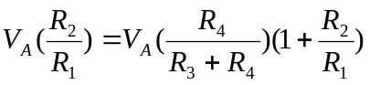, so
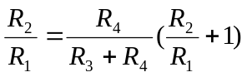
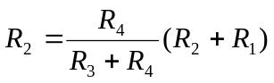
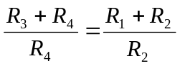

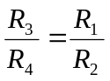
And
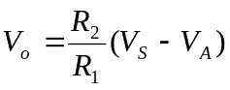

Equipments:

1- DMM/AC VTVM
1- 741 IC
2- 100KΩ Resistors
2- 10KΩ Resistors
1- 10K Pot

Procedure:

- 1. Connect the circuit shown below
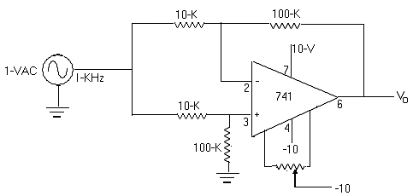

2. Adjust the offset null control for minimum DC Vo level.

3. Measure AC Vo level.
Vo = __________ VAC

44. 4. Calculate the common mode voltage gain (AC) = Vo/1VAC __________

5. 5. Modify the input circuit as shown below:

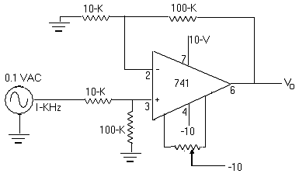
6. Measure Vo =_______ VAC

- Calculate differential voltage gain (AD) = Vo/0.IVAC = _____________

- Calculate common mode rejection ratio (CMRR)

CMRR = ______ db

Question:

1. What effect would be made on the output voltage if both inputs are driven with the same 100Hz signal but R₄/R₃ >> R₂/R₁?
2. As in question 1, but R₄/R₃ <<R₂/R₁?
3. Assuming zero offset and a perfect integrated circuit, calculate the output levels of circuits shown:

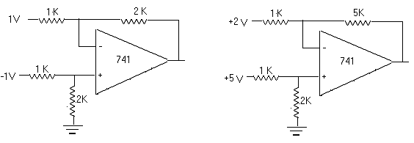

4. Answer as in question 3 for the circuit below:

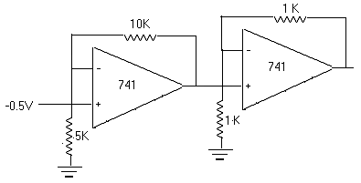

5. Answer as in question 3 for the circuit below:
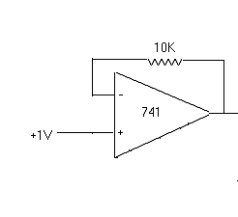

6. Answer as in question 3 for the circuit below:

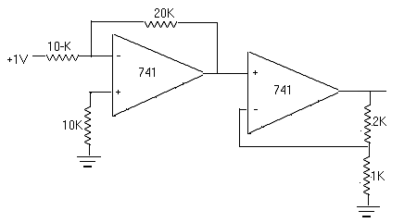
EXPERIMENT #5

WIEN BRIDGE OSCILLATOR

Objective: To acquaint the student with a popular RC audio oscillator.

Equipments:

1- 741 Op. Amp
1- 10KΩ pot
2- 10KΩ resistors
2- 1KΩ resistors
2- 0.01μF capacitors

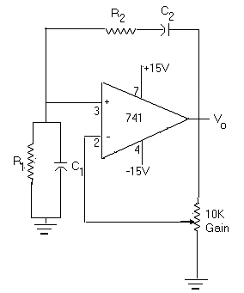
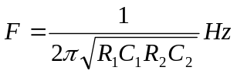
C₁=C₂=0.01μF
Procedure:

1. Connect the oscillator shown (R_{1’2} = 1KΩ) and while monitoring Vo with an oscilloscope and frequency meter adjust gain for a minimum distortion stable sine wave output.

Frequency = _____________Hz

2. Repeat step 1 with R_{1’2} = 10KΩ

Frequency = _____________Hz

3. Repeat step 1 with R₁ = l0KΩ; R₂ = 1KΩ

Frequency = _____________Hz

Questions:

1. Assuming perfect resistors and capacitors, calculate the frequencies of operation in step 1, 2, and 3.

2. Discuss what limits the highest sine wave frequency that could be produced by this type of circuit.

EXPERIMENT #6

LC OSCILLATCYRS

Objectives: To acquaint the student with two popular LC oscillators, the Hartley oscillator and
the Clapp oscillator.

Components:

1- 2N3569
1- 100KΩ
1- Tapped Coil
1- 0 mH coil
1- Variable Capacitor
2- 250 pf capacitors
1- 47 pf capacitor

Procedure:

- Connect up the Hartley oscillator and measure the frequency range.

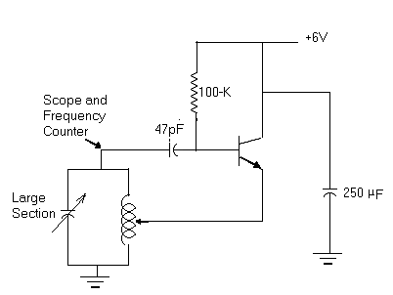

Frequency range: _______ Hz to ___________ Hz

- 2. Remove the scope and measure the frequency range.

Frequency range: _______ Hz to ___________ Hz

- Connect up the Clapp oscillator and measure the frequency range.

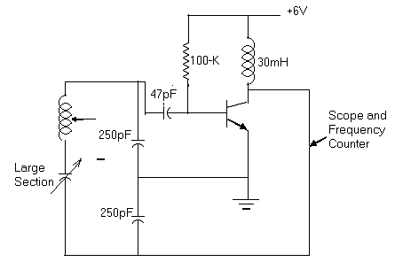

Frequency range: _______ Hz to ___________ Hz

4. Remove the scope and measure the frequency range.

Frequency range: _______ Hz to ___________ Hz

Questions:

1. Describe how positive feed back is obtained in each oscillator.

2. Explain the results of steps 2 and 4.
EXPERIMENT #7

TRANSISTOR REGULATORS

Objective: To acquaint the student with two simple transistor regulators.

Parts Required:
- DMM, DC Milliammeter.
- Zener Diodes: 1ZM12T5
- Transistor: 2N1011
- Resistors: 25Ω/l0W, 270Ω/2W, 470Ω/2W, 1KΩ/2W, 4.7KΩ, l0KΩ/2W, 10KΩ pot.

Procedure:

1. Connect the circuit shown in Figure 1 with R_{L} = l0KΩ.
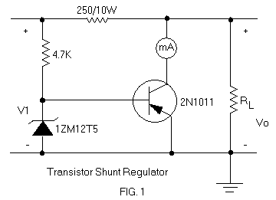

R_{L} | Vo | I_{E}(mA)
10K
1K
470
270
TABLE 1

2.

2. Adjust V₁ to 24 volts.

3. 3. Measure I_{E} and the voltage across R_{L.} Record in Table 1 for the various values of R_{L} shown.

4. With R_{L} = 470Ω slowly lower V₁ until Vo starts falling rapidly.

V₁ = _________________, I_{E} = _________________

5. Repeat step 4 with R_{L} = l0KΩ

V₁ = _________________, I_{E} = _________________

6. Turn off the power.

7. Connect the circuit shown in Fig.2 with R_{L} = l0KΩ

R_{L} | Vo | I_{E}(mA)
10K
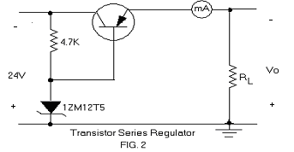
1K
470
270
Table 2

8. Repeat steps 2, 3 and record results in Table 2.

9. Repeat step 4.

V₁ = _________________, I_{E} = _________________

10. Repeat step 5.

V₁ = _________________, I_{E} = _________________

11. Make the modification shown in Fig.3.
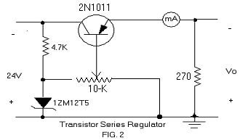
Vo | ΔVo | % Regulation
9v
6v
3v
1v

TABLE 3

12. Adjust the pot for Vo = 9 volts.

13. Change R_{L} to 10KΩ and record the change in Vo (ΔVo) in Table 3

14. Repeat steps 12 - 13 for the Vo values shown in table 3.

15. Make a graph of Vo versus R_{L} for the results shown in table 1.

16. Repeat step 15 for the results shown in table 2.

Questions:

1. Explain the operation of the circuit in Figure 1.

2. Explain the operation of the circuit in Figure 2.

3. Explain the operation of the circuit in Figure 3.

4. Explain the differences noticed in step 4 and 5.

5. Explain the differences in % regulation found in Table 3.
EXPERIMENT #8

IC VOLTAGE REGULATOR

Parts Required:

- DC Milliammeter
- Resistors: 47Ω, 100 Ω, 150 Ω, 180 Ω
- Capacitor: l μF
- LM140 Three Terminal IC

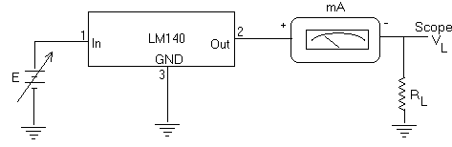
E | V_{L}
1
5
10
11
12
13
14
15
Fig 1

R₂ | Vo | Io
47
100
180

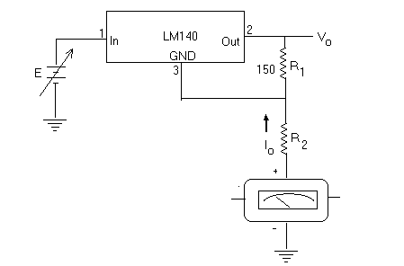

Fig2

Procedure:

1. Connect the circuit of Fig.l

2. Increase E from lv to l5v.

3. Observe the display on the scope (all you see is a solid dc voltage. If any oscillation exists, connect 1μF across E.)

4. Adjust the input for the values shown in the table and record the output V_{L}.

5. Connect the circuit of Fig.2 for all R₂ as shown in the table 6.

6. Measure and record Vo and I_{L.}

Questions:

1. For what Vi (min) was regulation maintained?

2. Calculate Vo for I_{Q}= 8mA and R2 = 100Ω.

3- What does the data tell you?

